
IDBI APIM Platform

WebMethods API Portal Installation and Setup Guide

Software AG

OS Level Settings
OS Level Updates with root user

sysctl -a|fgrep fs.file-max
sysctl -a|fgrep kernel.shmmax
ulimit -Hn
ulimit -Sn

Update the /etc/hosts file

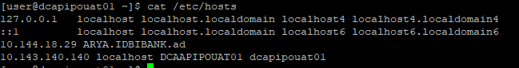

/etc/security/limits.conf

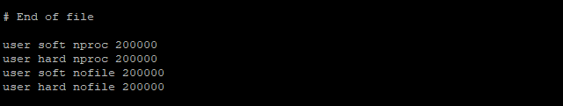
/etc/sysctl.conf

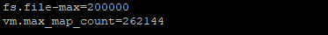
execute the command sysctl -p for the above changes to take place

Product Installation

/data/binaries
./SoftwareAGInstaller20210826-Linux_x86_64.bin -readImage ./SAG_Linux_10.7_x64-9SEP.zip
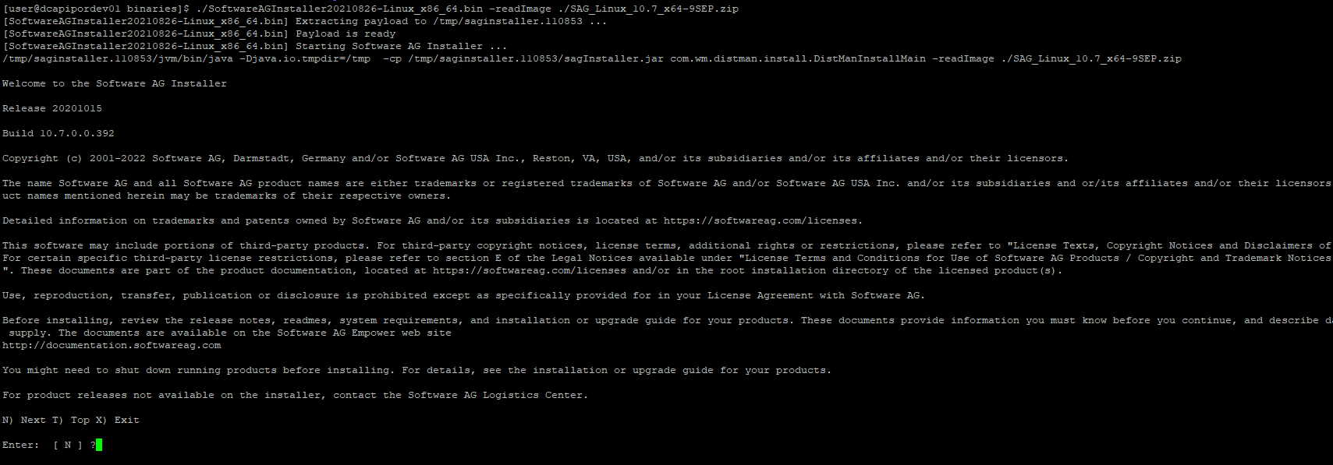
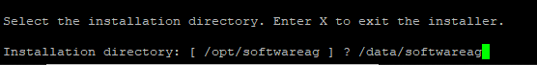
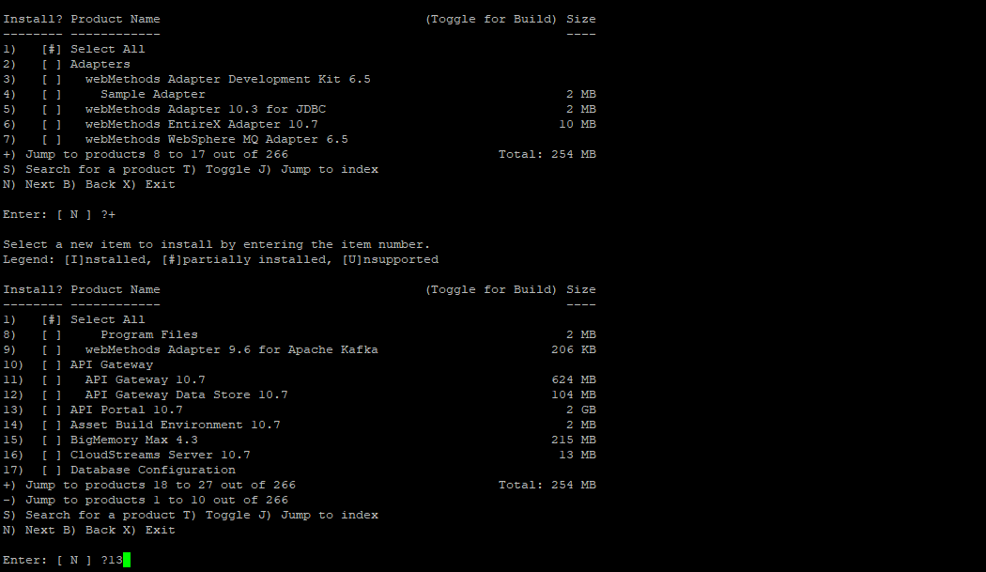
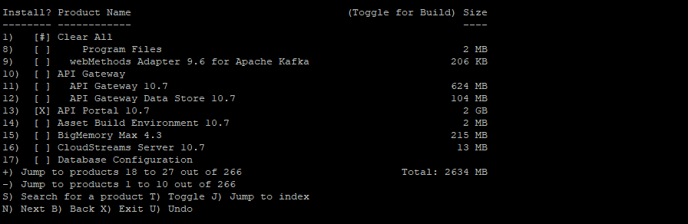

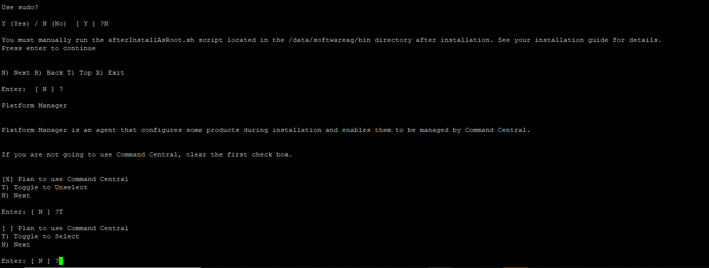

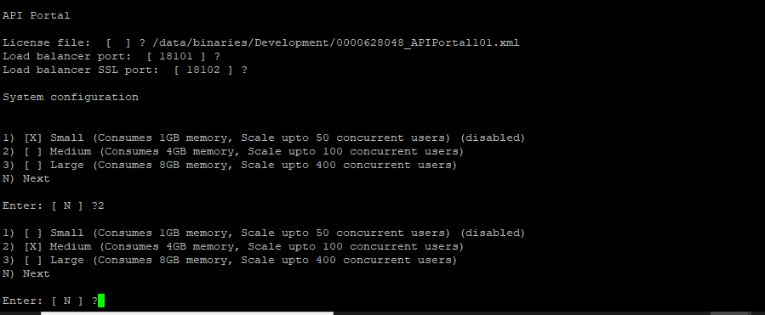
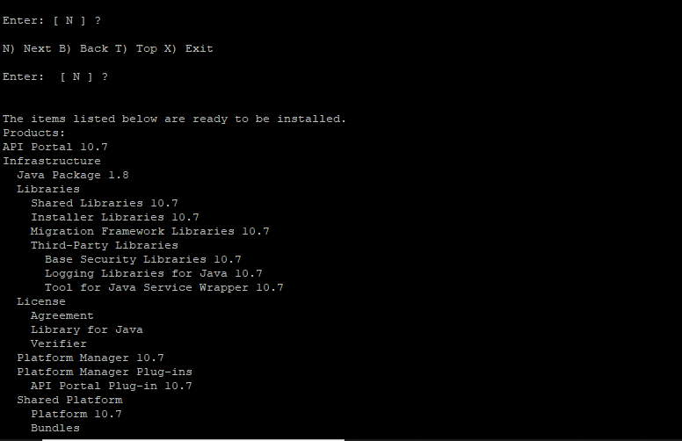

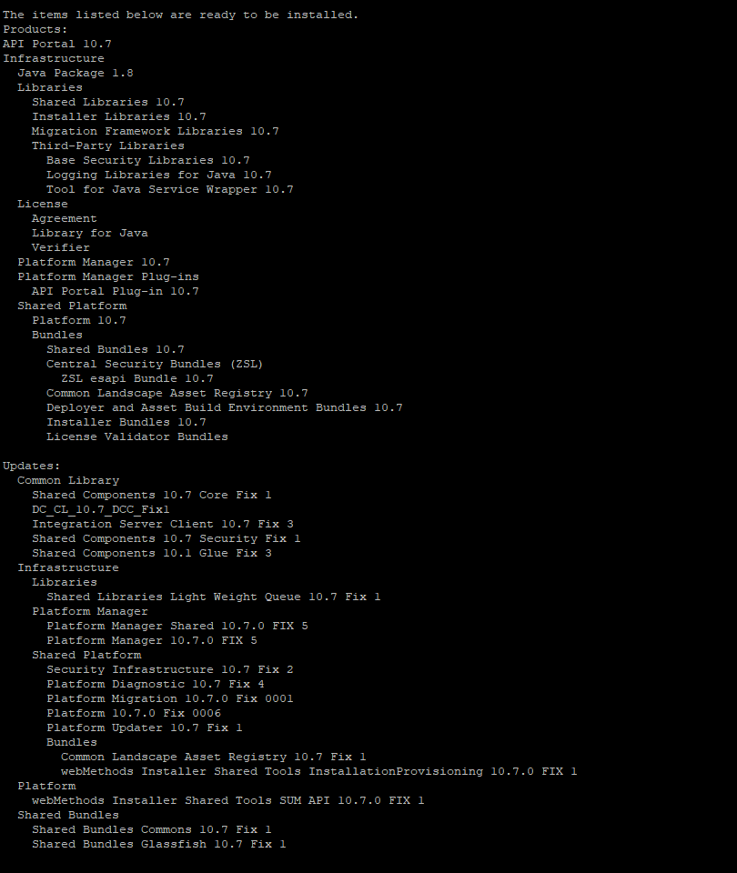

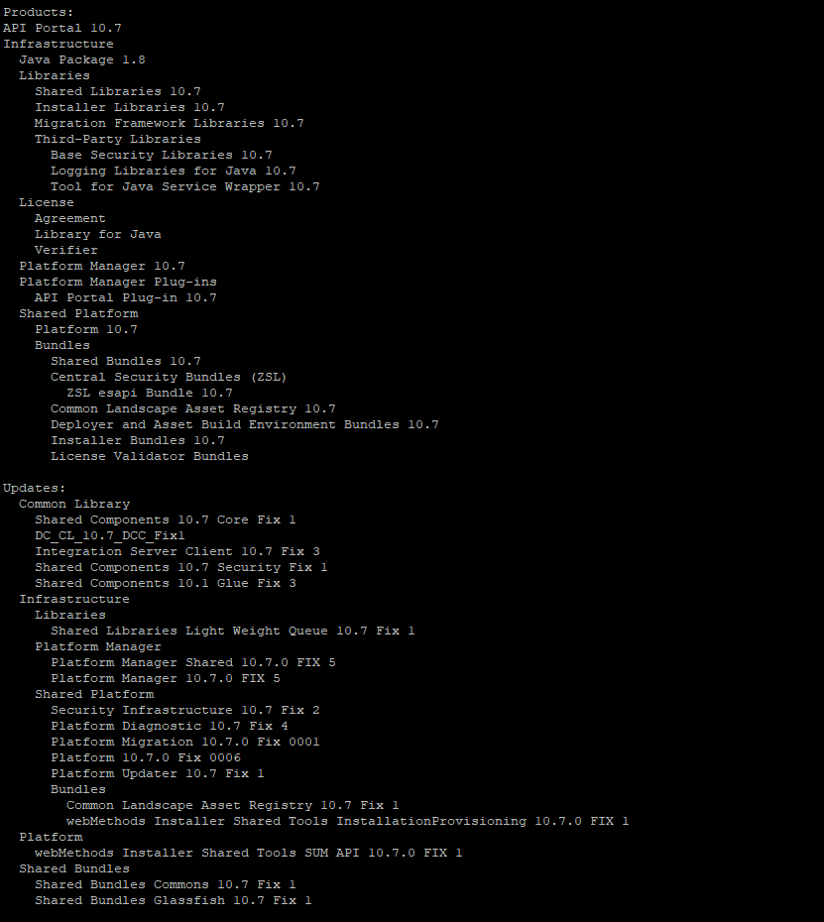

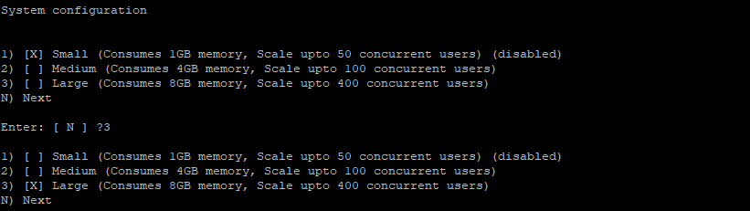
DR

Start and Stop API Portal

Go to the installation directory /data/softwareag/API_Portal/server/bin

execute the below to start the CloudAgent if its not running
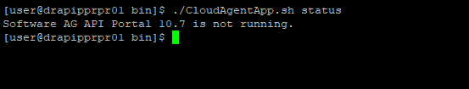
Start the Cloud Agent by using the below command

./CloudAgentApp.sh start

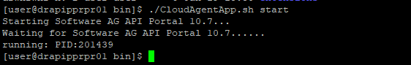

Next start the API Portal Cloud Controller (ACC)

cd /data/softwareag/API_Portal/server/acc

./acc.sh -h localhost -u Clous -pwd g3h31m -p 18012

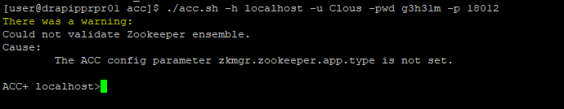

Once you have connected to the controller, you can perform the Admin activities such as start/stop of the API Portal conponents.

Execute list to check the current status of the all the API Portal components

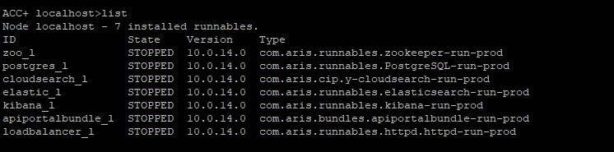
Importing the SSL certificate.

Create a certificate zip file containing the server.key and server.crt. For Dev it is apim_dev.crt and apim_dev.key and UAT apim_uat.crt and apim_uat.key

Copy the zip to the API Portal server to /data/binaries/certs

Connect to the acc controller to import the certificate zip.

Stop the load balancer instance of he API Portal instances by running the below

cd /data/softwareag/API_Portal/server/acc
./acc.sh -h localhost -u Clous -pwd g3h31m -p 18012

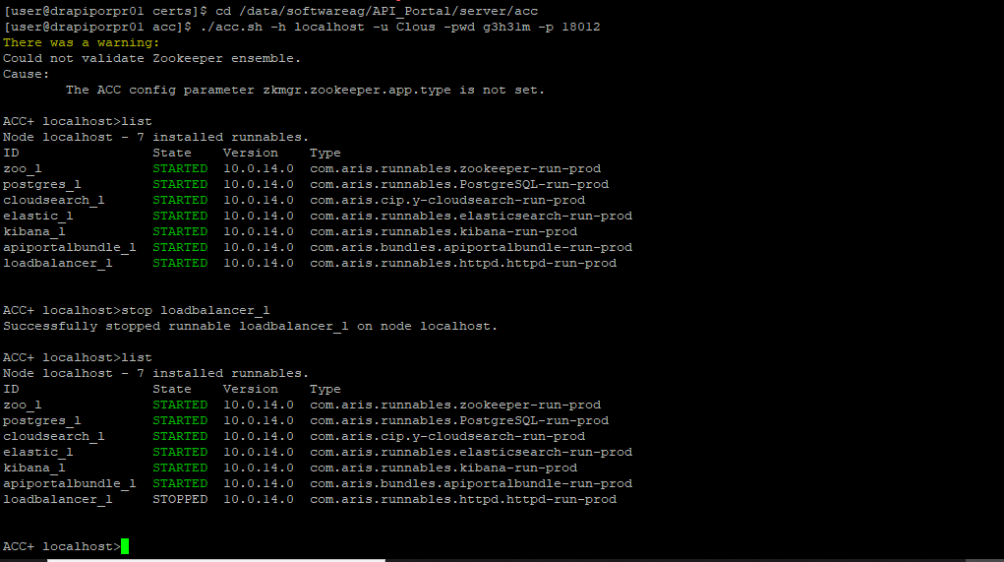
now execute,

enhance loadbalancer_l with sslCertificate local file "/data/binaries/certs/certs.zip"

enhance loadbalancer_m with sslCertificate local file "/data/binaries/certs/DEV_certs.zip"

enhance loadbalancer_m with sslCertificate local file "/data/binaries/certs/UAT_certs.zip"

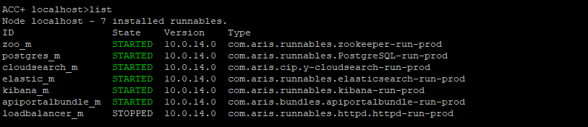

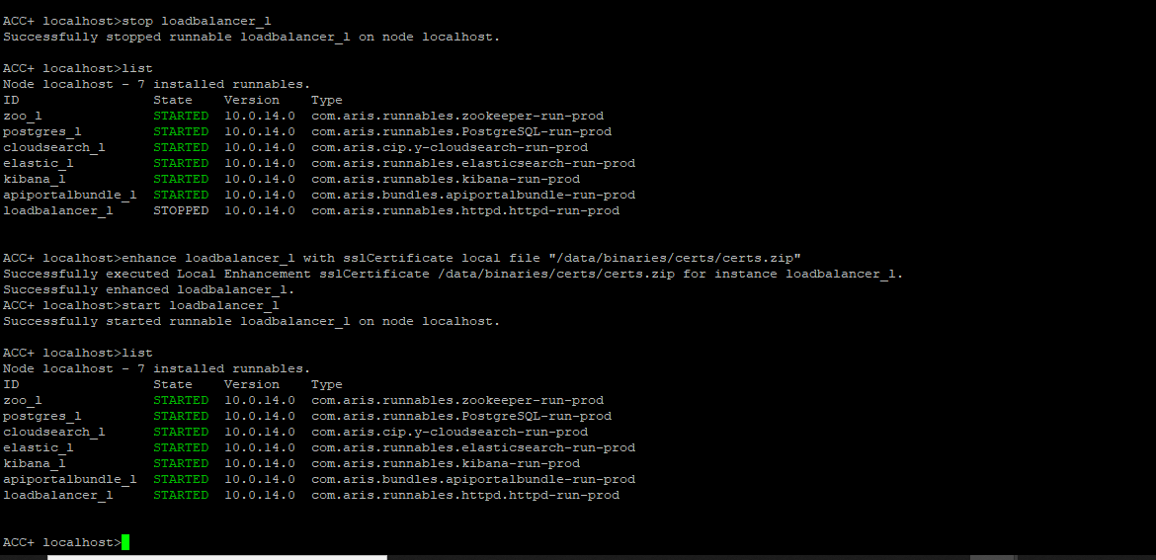

Exit from the controller plane

Once all the components are up it will show the status as below

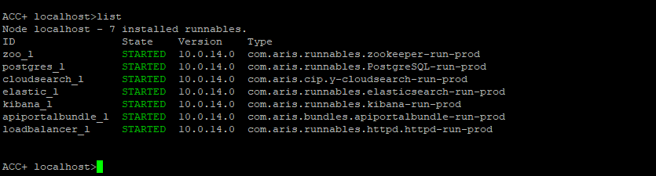
and the Port status would be.

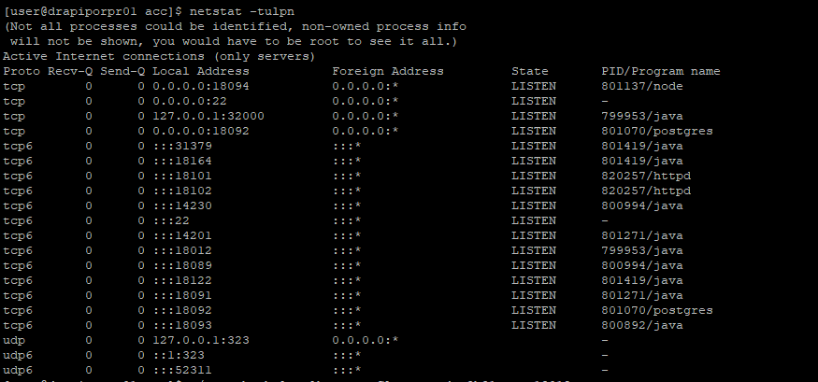
Changing the default password for ACC

Login to acc controller plane.

Stopall components

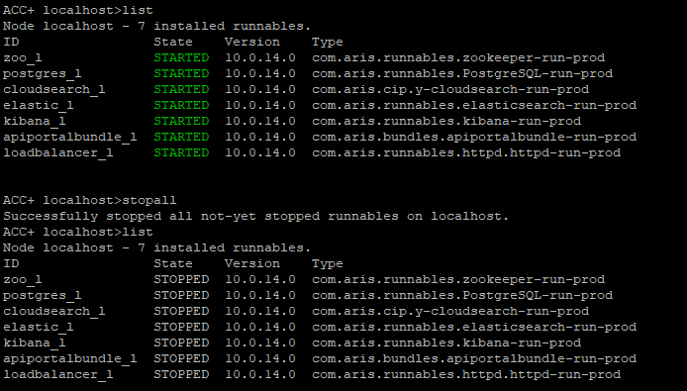
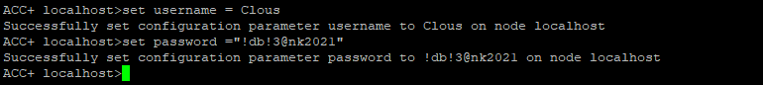
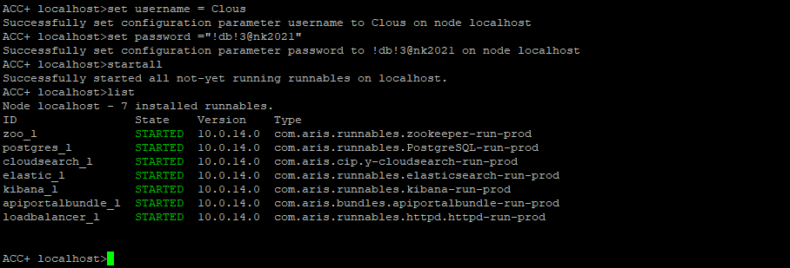

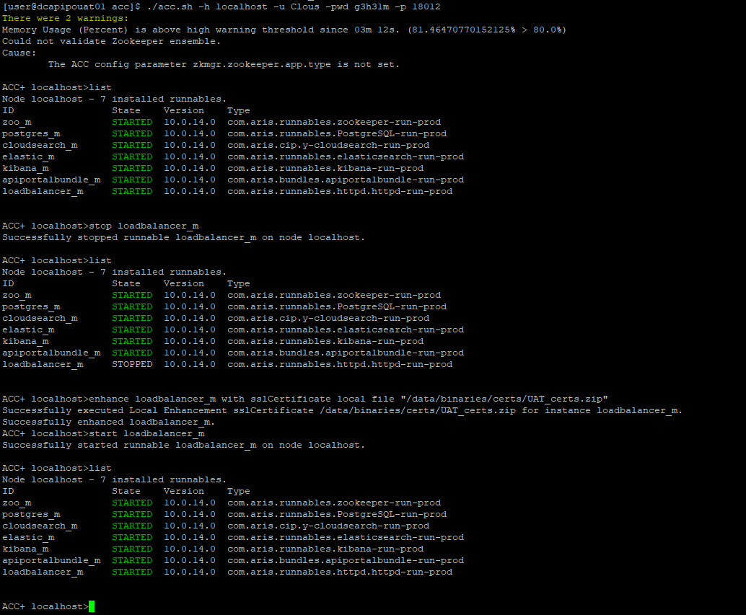
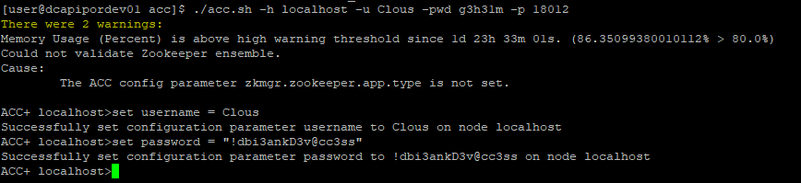
set username = Clous
set password = "!dbi3ankD3v@cc3ss"

After setting the password. Start all the components.

Now, next time onwords you should login to ACC by using the new password .

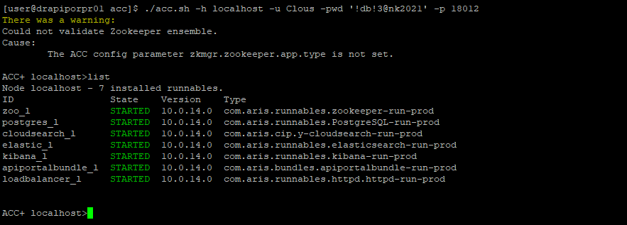

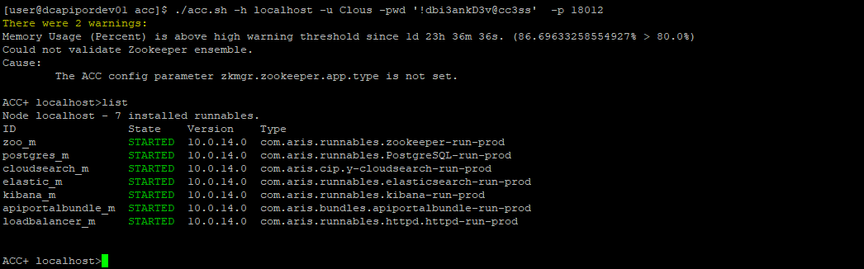
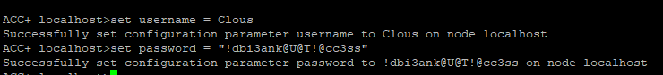
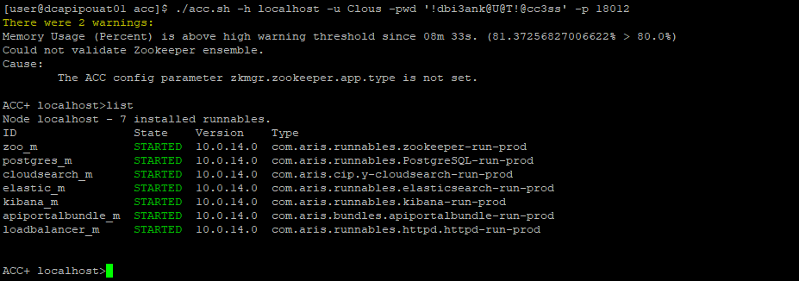
Once the API Portal is accessible from the Browser. You can then export the IDBI Skins into the API Portal.

The screen shot is captured for UAT. However, the procedure remains the same for DEV, DR and PROD.

Access the UAT API Portal link.

https://dcapipouat01:18102/

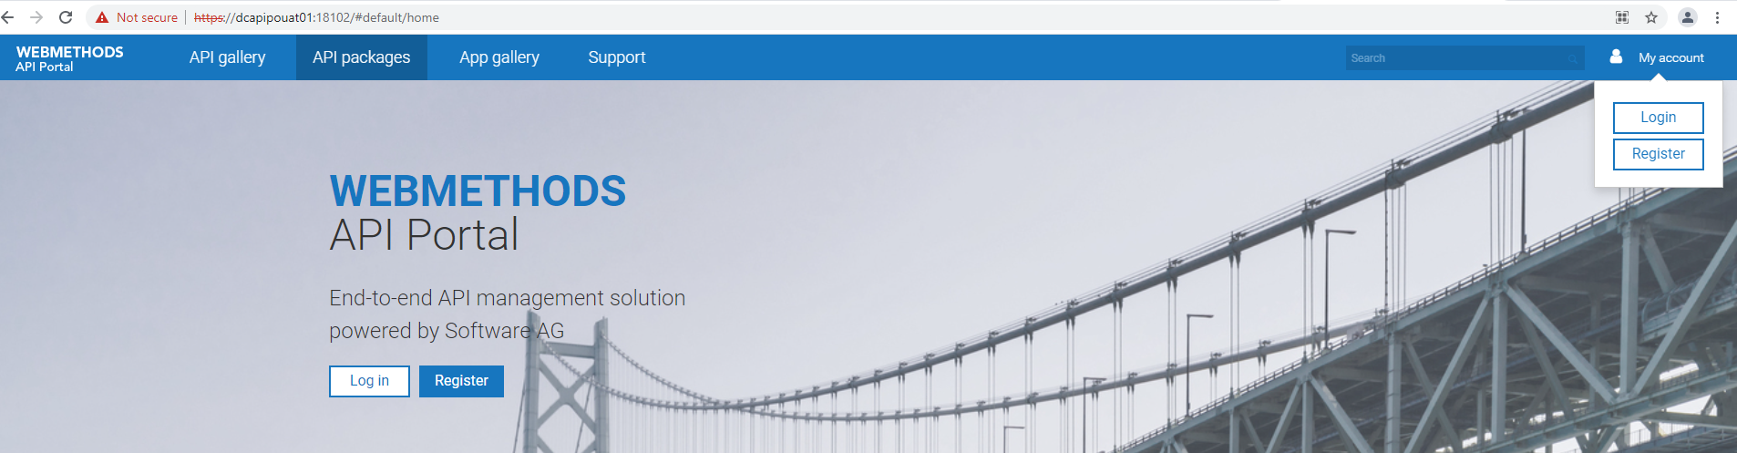
Click on the user icon on the top right corner

Login with the user: system and password: manager

Again click on the user icon on the top right corner and then click on the option “Administration”

Applying Custom Skin
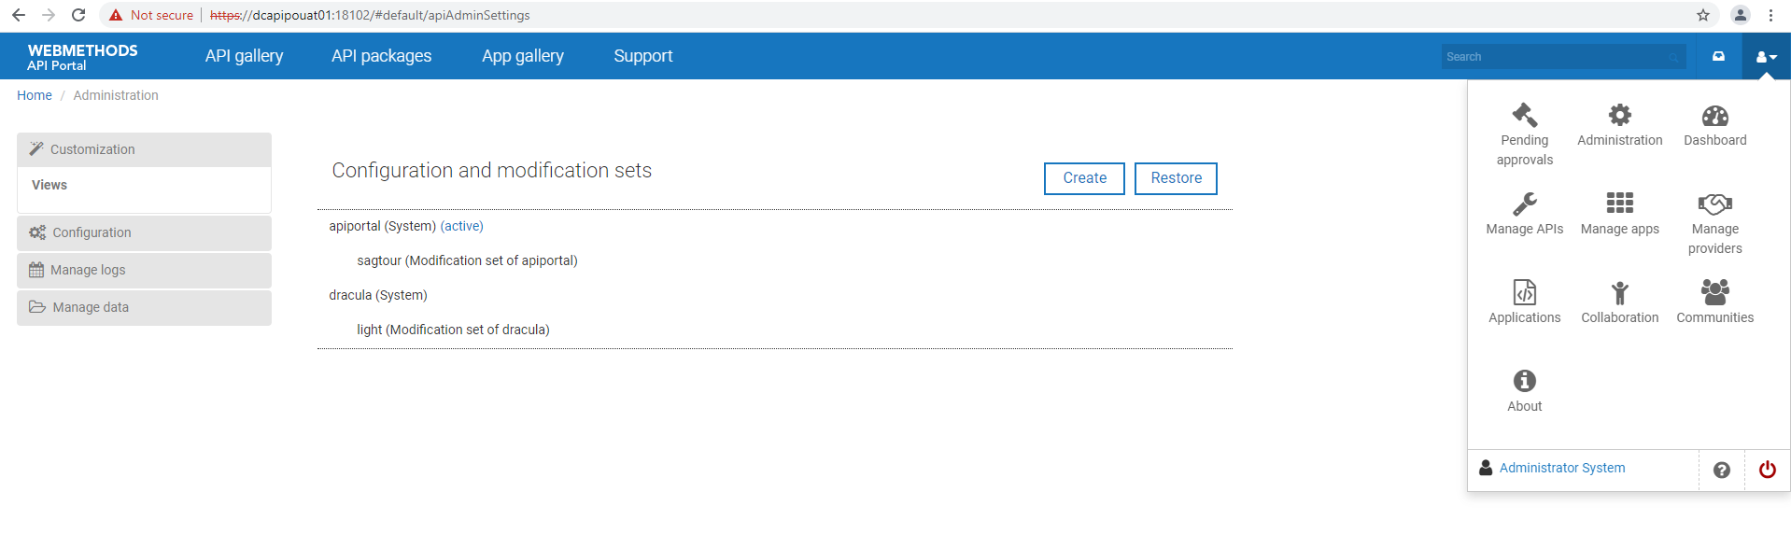

Click on the Restore button and upload the file asiasales.IDBI_colorful.zip from local.

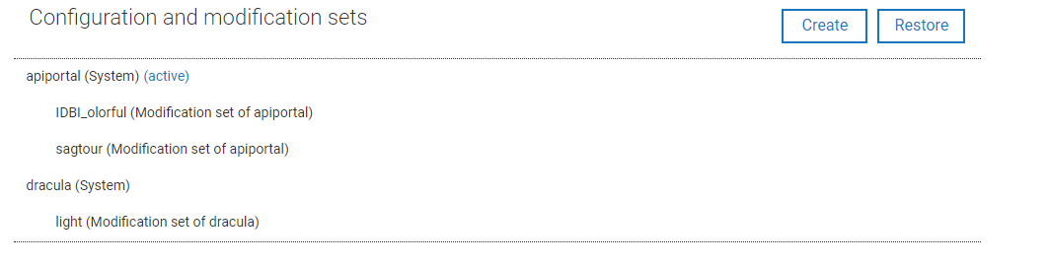

An entry will be created with IDBI_colorful. Now however the cursor on this and select the arrow mark as activiate option to activiate the skin.

The skin will be immediately updated as shown below

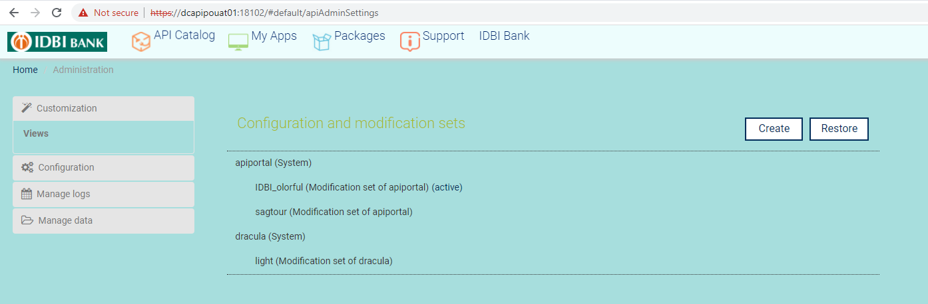
Once you now re-load the page you can now see the login page appearing with the IDBI skin

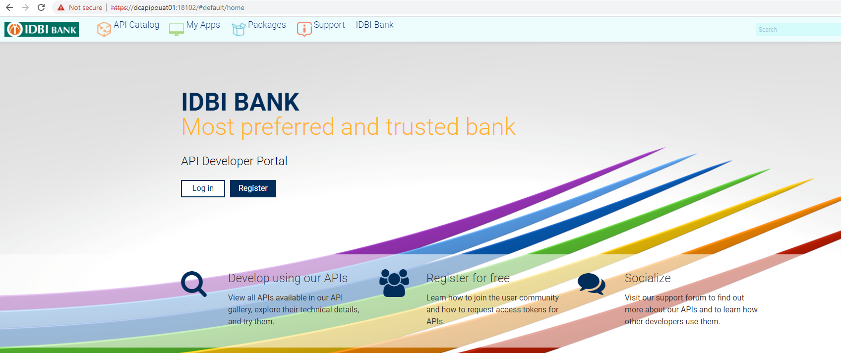
Repeat the same step for importing the skin for the other environment.

Prod API Portal:

https://10.142.15.245:18102
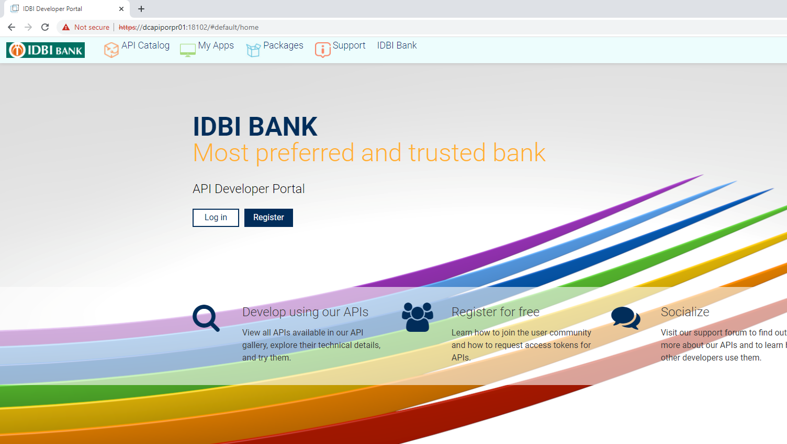

DEV API Portal:

https://10.143.140.131:18102

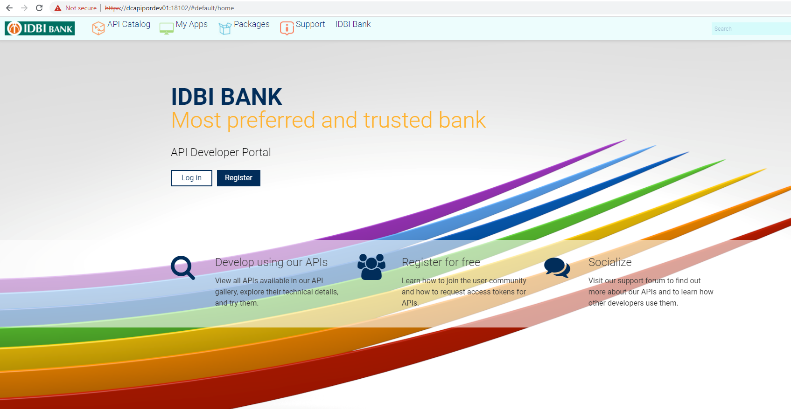
UAT API Portal:

https://10.143.140.140:18102

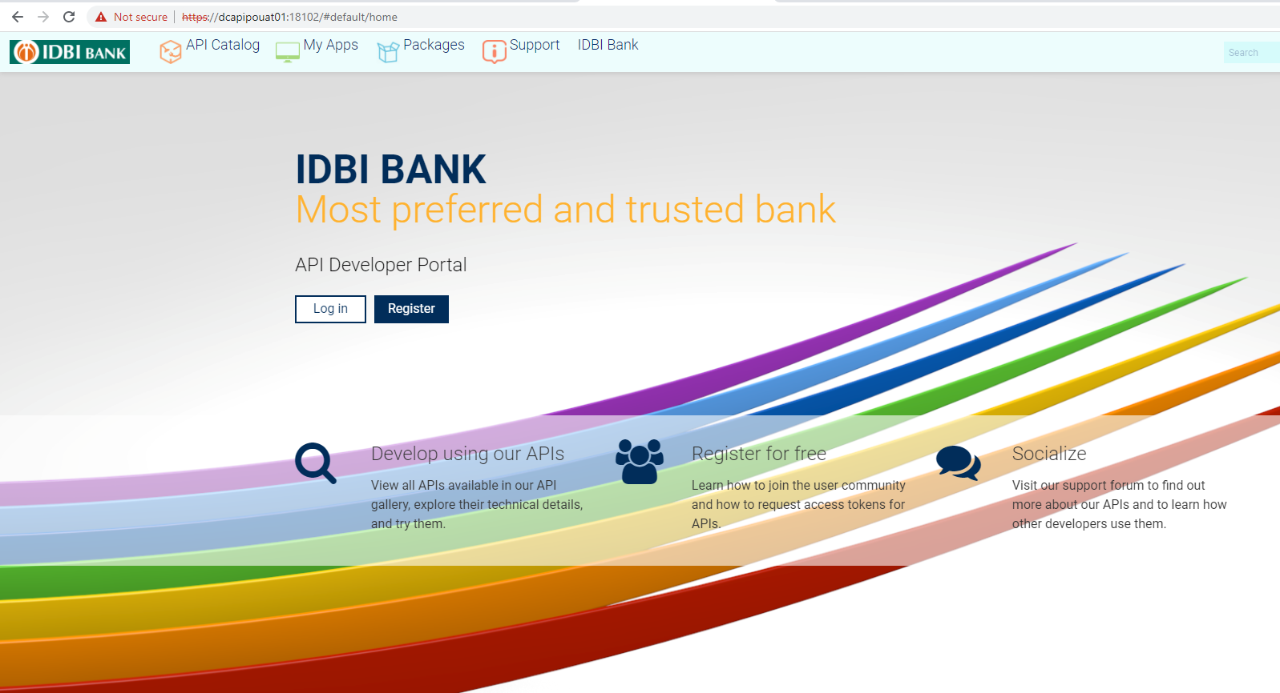

DR API Portal:

https://10.172.19.245:18102

